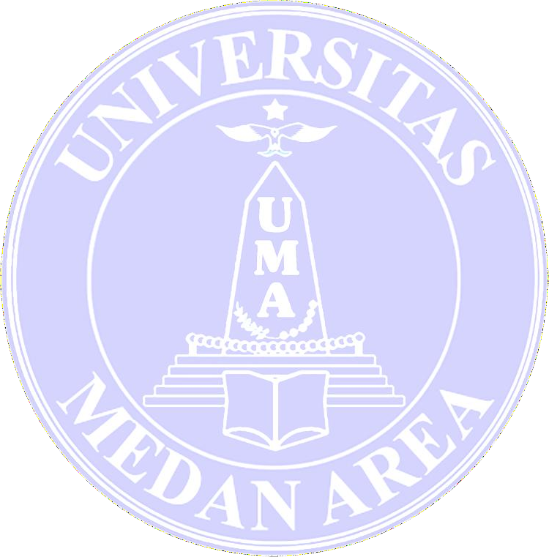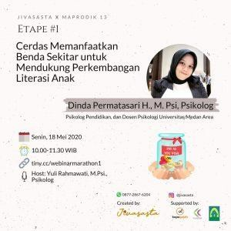Lecturer in the Faculty of Psychology became a resource at the Marathon-Psychology Life-Hacks Webinar

Marathon-Psychology Life-Hacks Webinar is a webinar held by Jivasasta in collaboration with Psychology alumni of the 13th Professional Psychology Master in Educational Field at Gadjah Mada University. One of the Psychology alumni of the Professional Psychology Masters in education is a lecturer at the Faculty of Psychology, University of Medan Area, namely Dinda Permatasari Harahap, M.Psi, Psychologist.

Dinda Permatasari Harahap, M.Psi, a Psychologist who is also the Head of Development Psychology at the Faculty of Psychology, University of Medan Area, was a guest speaker on the Marathon- Psychology Life-Hacks Stage # 1 theme with the theme “Smart Utilizing Nearby Objects to Support the Development of Children’s Literacy “on Monday, May 18, 2020, at 10:00 WIB until completion. This activity is carried out through the Google Meet service.

The event was hosted by Yuli Rahmawati, M.Psi, a Psychologist who is also the CEO of Jivasasta. The webinar participants were very enthusiastic about the material presented, especially to find out what literacy is, why literacy is important for children, how the role of parents to stimulate child literacy, factors that influence the development of children’s literacy, to the explanation of the media used to increase children’s literacy.

This webinar is expected to help parents to provide as much literacy as possible to their children easily. One of them uses Environmental Print media, which uses objects around us as learning media for children, such as colorful food packages, so that children love to learn the letters and writing contained in these packages.

